Bug Bounty

Steps what I followed when doing Bug Bounty.
- I had to learn some new topics

HTTP — TCP/IP Model
Linux — Command line
Web Application technologies.
Networking basics
Learning Basics of HTML, PHP, Javascript etc.

- I did fascinate the web security more than mobile, hence I focused more on
- Web Application Security Basics.
- OWASP Top 10 for 2010 OWASP top 10 for 2013 OWASP top 10 for 2017
- OWASP Testing Guide V4

- Books that I use, & hope to use in the future.
- Web Application Hacker’s Handbook
- Mastering Modern Web Penetration Testing
- The Hacker Playbook 1, 2 and 3
- The Mobile Application Hacker’s Handbook
- Breaking into Information Security
- Web Hacking 101

Hacker101 CTF Writeup

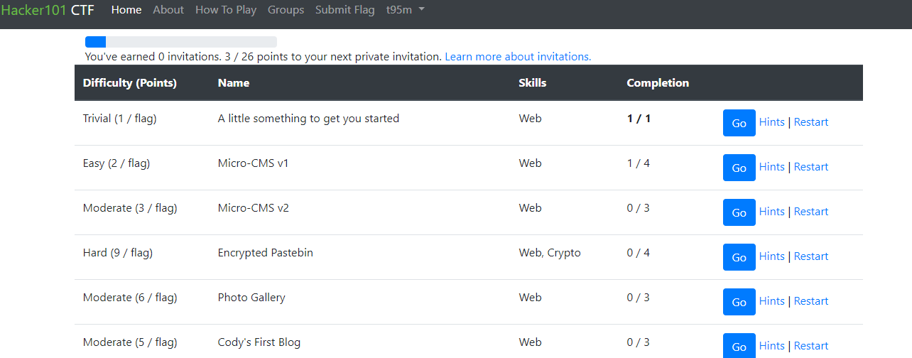

- A little something to get you started (Trivial (1 / flag))

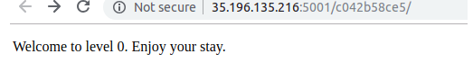
Click on go to get a page as shown below in the image.
As there is nothing to be viewed, I clicked on the hint, which directed me to check the source code.

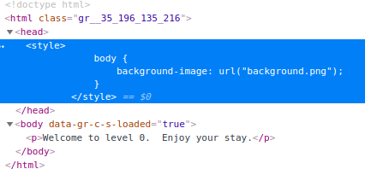
As there was no background image included, it became suspicious. But there was no place to use this image. So, I tried it on the URL. And luckily after few trials, it worked.
- Micro-CMS v1 (Easy (2 / flag))

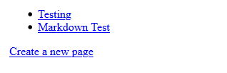
This is the 1st screen visible. I clicked on the create a new page link, as there was nothing extra ordinary in the source codes.
The URL had the most fascinating thing, where the Testing page showed the ID of 1, Markdown Test link showed the ID 2. The new page that I made showed the ID 9, & to make sure I made another, it showed 10. (All are in the video)
Seemed like the pages, 3 to 9 were missing. That was the 1st clue in got.
I went on planting values as the ID. The # were 3 to 9. I dint know it would work. So, I tried #1, & fortunately it led me the 1st age. Thus, my assumption was correct.
Every # i placed, gave me a Not Found indication, except the # 7.
Which said that the page was forbidden to view.

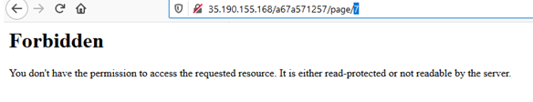
Meaning, this is where the secret was hidden.
As there was a Edit page link, that seemed so irrevalant, I tried to edit the 1st page. The result was normal, but I understood that there was another set of URLs, that ends with page/ edit/ #.
When I used, # 1, it took me to the 1st page that I edited. Thus, I straight away, used # 7.
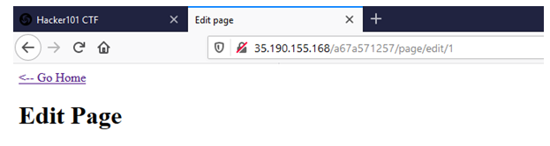

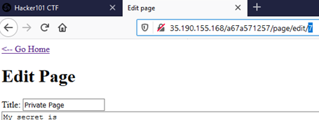

- Micro-CMS v2 (Moderate (3 / flag))

This one I’m still trying to figure out, it seems to use a SQL Union, maybe. But not sure.
The user name, password entries made me confused. But remembering something from SS, used a “’”. It didn’t give me much. So, I didn’t proceed.

- Encrypted Pastebin (Hard (9 / flag))
I started this out of curiosity, couldn’t end it though.
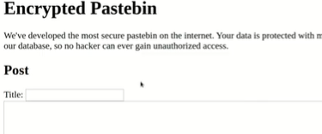
I opened this portal, added a title & content and posted it.
I still couldn’t figure out what to do next.

Hack the Box

I have kind of just started with Hack the Box, & something small that I have done, is uploaded in the video.

Extra

I have done a simple program scan, using nikto, which is just a basic tool. My knowledge using burp suite is still not adequate, and I’m still on the run of learning it. Everything done for that scan is uploaded in the video.

